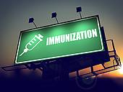

RECENT UPDATES IN VACCINES: LATEST CDC
RECOMMENDATIONS
Date: Wednesday, Oct. 26 4:00 – 5:00 pm
Location: Chatham Eastside, Room TBA
*Event is free and open to all Chatham Students, Faculty, and Staff

Speaker: Chad Rittle, DNP, MPH, RN, FAAOHN
**Sponsored by Chi Zeta/Nursing

